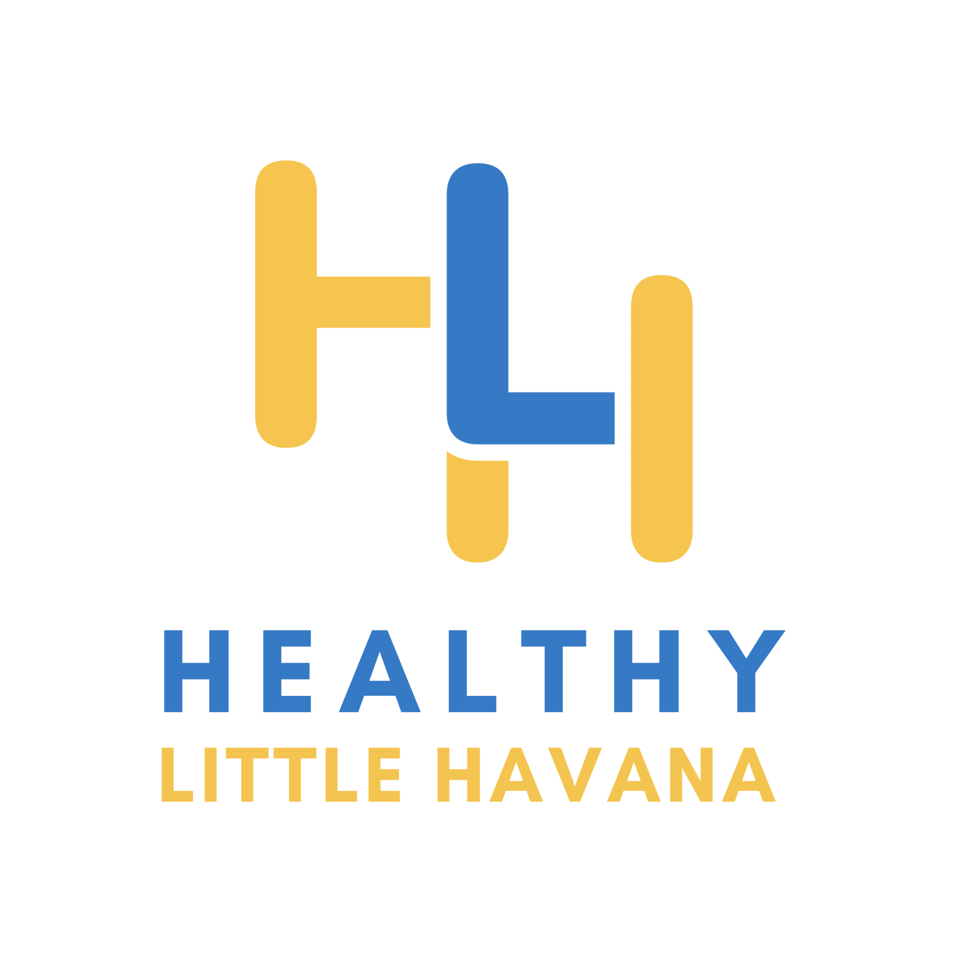
Position Title: Program Manager
Effective Date: April 4, 2022
Salary: $58,240

ORGANIZATIONAL OVERVIEW:
Healthy Little Havana (HLH) aspires to create a health-supportive neighborhood where all Little Havana residents can thrive. Our mission is to support and advocate for efforts that strengthen Miami's Little Havana neighborhood by focusing on the social determinants of health. Based on our Community Action Plan (CAP), our activities are separated into the following four health priority areas: education to employment, public space, healthcare access, and housing. More information about our work can be found at www.healthylittlehavana.org.

POSITION OVERVIEW
The primary responsibility of the Program Manager is to work with the HLH Director of Social Determinants and Health Equity to implement the current strategies outlined in the organization’s Community Action Plan (CAP). The Program Manager will manage projects related to the maintenance and growth of the social determinant of health focus areas within HLH to achieve the CAP strategies. This position also involves growing and maintaining relationships with municipalities, government officials, committees, agencies, community partners to effect policy, systems, and environmental changes. HLH currently has projects around climate resilient affordable housing, COVID-19 vaccine hesitancy, small business incubation, and building community capacity and advocacy around accessible public spaces.

This is a full-time position where the number of hours needed to complete tasks may fluctuate depending on project and initiative demands. While there will be some on-site or on-the-field hours required, there is significant flexibility to work virtually and to set your own schedule. Compensation will be commensurate with experience and could include benefits such as health, insurance, vacation, sick, and holiday paid time off.
RESPONSIBILITIES
The Program Manager provides leadership, management, coordination, and implementation of project deliverables. Other key responsibilities include:

Primary Functions
- Plans and implements projects from start to completion, in collaboration with HLH leaders and staff
- Ensure regular coordination, evaluation, and attention to detail across multiple projects with shifting priorities and schedules.
- Project monitoring, assessment, and evaluation. Leads and supports community assessment effort and guides and assists the development and implementation of project and initiative evaluation plans.
- Budget management and reporting. Manages assigned budgets, prepares, and submits reports as requested and/or outlined in project grant deliverables.
- Outreach planning and implementation; Coordinates events and leads community outreach planning in partnership with the team. Supports community engagement and capacity building, advocacy, and the implementation of UHP’ Community Liaison Framework where residents of Little Havana are hired, trained, and supported in becoming champions for health equity.
- Builds relationships with relevant partners and stakeholders.
- Works closely with team and provide day-to-day supervision to ensure all deliverables are met.
- Develops and assists in the delivery of presentations to varied audiences and in the preparation of reports.
- Supports grant research, writing and applying for funds to grow the initiative, projects, and team.
- Other duties as assigned.

General Conduct
- Displays an attitude and behavior that reflects the organization’s mission and core values of: collaboration, community, empowerment, equity, and integrity
- Displays a positive and professional approach toward staff and community members and consistently works in a collaborative manner
- Values diversity and actively contributes to a respectful and inclusive work environment
- Works well independently, including in a virtual environment and with initiative
- Has demonstrated ability to organize, plan, and prioritize work and makes efficient use of time and resources
- Is comfortable with learning and utilizing new software and digital tools
- Has excellent communication and interpersonal skills
- Conducts themselves in a professional manner
- Communicates openly and effectively with supervisors, staff, community organization personnel, community stakeholders, community members
- Follows directions with little supervision and with high efficiency
- Works well under pressure
- Maintains a high degree of accuracy and prevents errors directly impacting the implementation of the initiative
- Organized and detailed oriented
EDUCATION AND EXPERIENCE REQUIREMENTS
This is an outstanding opportunity to play a critical role in strengthening the Little Havana neighborhood through the social determinants of health. Therefore, first and foremost, the Program Manager must be committed to the mission and overarching goals of Healthy Little Havana. Additionally, the successful candidate will be able to demonstrate:

- Bachelor’s Degree in public health, social work, urban or environmental planning or related field supplemented by at least (3) years of experience in public health or related field and two (2) years in program or project management or a supervisor role; or an equivalent combination of education, certification, training, and/or experience.
- Demonstrated experience working in an outreach and engagement capacity.
- Demonstrated experience working with vulnerable and/or historically disenfranchised communities.
- Demonstrated experience leading a team.
- Knowledge of needs, issues, and services related to policy, social and built environment and/or health and the ability to create and conduct educational programs for a variety of audiences.
- Demonstrated desire to work with issues related to health equity including policy, systems, and social and built environment .
- Demonstrated leadership and project management skills.
- Comfort with ambiguity and ability to thrive in a fluid, entrepreneurial environment; willingness to “roll up one’s sleeves” and extend beyond formal responsibilities based on the needs of the work
- Advanced skill level of knowledge in:
  - Computers (Google Suite/Microsoft Office)
  - Excellent written and verbal communication skills
  - Ability to learn and become proficient in the use of other specialized software as may be required
Desired Qualifications
- Master’s degree in public health, social work, and/or urban or environmental planning or related field and experience supervising or managing comprehensive public health programs including outreach planning, coordination and evaluation.
- Fluent in Spanish and English (oral and written) is highly desirable.
- Knowledge of local jurisdictions and policy process and advocacy techniques.
- Experience with research, program evaluation, and assessment.
- Knowledge and experience in communications and media to effectively engage partners and residents.
COMPENSATION
- Starting at a base salary of $58,240, commensurate with experience.

Deadline: Position will be open until filled, but apply before March 15, 2022, for full consideration. Estimated start date is April 4, 2022.

Consistent with HLH’s values in diversity, equity, and inclusion, the team seeks to build a vibrant organization where all individuals, regardless of background, can feel valued and contribute fully to the mission. In accordance, HLH does not discriminate on the basis of race, color, religious creed, national origin, ancestry, sex, sexual orientation, age, genetic information, military service, or disability.

