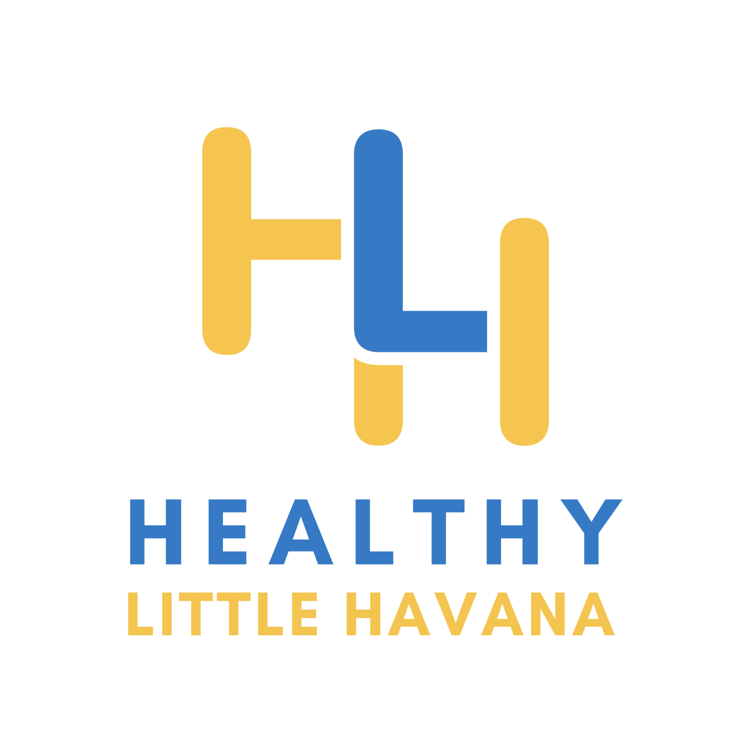
Director of Health Equity and Social Determinants of Health
Healthy Little Havana

Position Title: Social Determinants of Health and Health Equity Director
Effective Date: April 4, 2022
Salary: $70,000

ORGANIZATIONAL OVERVIEW:
Healthy Little Havana (HLH) aspires to create a health-supportive neighborhood where all Little Havana residents can thrive. Our mission is to support and advocate for efforts that strengthen Miami's Little Havana neighborhood by focusing on the social determinants of health. Based on our Community Action Plan (CAP), our activities are separated into the following four health priority areas: education to employment, public space, healthcare access, and housing. More information about our work can be found at www.healthylittlehavana.org.

POSITION OVERVIEW
To lead this important work, Healthy Little Havana is seeking a passionate and entrepreneurial Director of Health Equity and Social Determinants of Health. The Program Director will be a visionary, dynamic leader who can grow and lead Healthy Little Havana, facilitate the collective success of the Community Action Plan, and serve as a public ambassador for the organization. More specifically, the Director will also drive Healthy Little Havana’s internal and external functions, including business development, strategy, communications, community engagement, and data functions.

This is a full-time position where the number of hours needed to complete tasks may fluctuate depending on project and initiative demands. While there will be some on-site or on-the-field hours required, there is significant flexibility to work virtually and to set your own schedule. Compensation will be commensurate with experience and could include benefits such as health, insurance, vacation, sick, and holiday paid time off.
RESPONSIBILITIES
The Program Director will manage staff and systems and be accountable for nurturing the efficiency and effectiveness of both, providing high-level strategic thinking and facilitation of the Healthy Little Havana’s effort. Key responsibilities include:
Leadership:
- Provide visionary, adaptive leadership, modeling HLH’s guiding values at all times and fostering a culture that reflects them;
- Developing, coaching and mentoring HLH team members;
- Establishing, facilitating, and executing effective and open communication with staff, particularly related to internal decisions and strategy;
- Developing systems to share organizational decisions with the HLH Board of Directors, SubCommittees, and staff members; and
- Identifying capacity gaps and creating hiring plans that acknowledge and plan for possible organizational growth and shrinking.
Organization Mission and Strategy:
- Works with Board and staff to ensure that the mission is fulfilled through the Community Action Plan (CAP), the work of the SubCommittees, and community outreach.
- Oversee the development of a local set of strategies that will drive transformative change in Little Havana
- Maintaining understanding of current implementation challenges and developing comprehensive solutions to address them;
- In concert with relevant workgroups, developing annual legislative agenda, policy and funding recommendations with guidance of the HLH Board of Directors;
- Providing direction and support to partner organizations in aligning their work to the Community Action Plan (e.g., identifying opportunities for program work to support specific goals);
- Developing strategic and advocacy priorities and coordinate supporting activities of partners.
Board Governance:
- Providing support to Board of Directors to facilitate meetings, assisting in preparation of meeting materials, etc.;
- Providing regular reports on progress against goals and indicators; and
- Building and maintaining relationships with Board of Directors, SubCommittees and workgroup members.
Financial Performance and Viability:
- Identifying potential funding sources to support HLH’s goals and priorities:
  - Writing grants, as needed, and/or overseeing all fundraising and development work
  - Working with implementing agencies to provide information to support their grant applications
  - Overseeing HLH’s grant reporting to funders as required
- Providing support and guidance to partner organizations in aligning resources to HLH’s agenda (e.g., supporting identification of grant opportunities that align to HLH goals);
- Tracking all HLH funding, including funds from partner organizations; and
- Developing relationships with potential funders and participating in relevant networks.
- Supervise the Operations and Finance Coordinator in the management of operational systems, administrative and reporting procedures, and people systems
- Oversee all audit and review activities, financial reporting, and tax filings
Working with community partners:
- Coordinating research and other activities with initiative partners to minimize redundancies and to align strategies and actions, including conducting individual outreach and education as needed;
- Updating outreach strategy as new needs emerge;
- Coordinating with other projects and coalitions in the same field to maintain a full understanding of the current landscape of local and regional activities, and integrating their work into SubCommittees and workgroup processes; and
- Building and maintaining relationships with community partners.
- Enhancing HLH’s image by being active and visible in the community and by working closely with key stakeholders.
Communications:
- Communicating the objectives of Healthy Little Havana to the community and potential partners, including sharing the Community Action Plan or other collateral;
- Facilitating communication between Healthy Little Havana partners and local prevention and treatment agencies by hosting regular conference calls, in-person meetings, or coordinating regular email updates to ensure alignment of activity;
- Creating or managing creation of yearly summary reports of Healthy Little Havana progress for Board of Directors, SubCommittees, and external audiences; and
- The following duties may be done in coordination with a communications consultant or staff:
  - Developing communications materials as Healthy Little Havana evolves, potentially including summary documents, brochures, FAQs, and other items;
  - Developing web and social media strategy; and
  - Creating press strategy, including drafting press releases, coordinating with media outlets.
Facilitation and Stakeholder Management:
- Build HLH’s identity as a respected, neutral convener among a broad spectrum of local stakeholders
- Cultivate excellent working relationships with senior education and community leaders involved in this initiative in a way that can inspire collective action without formal authority
- Ensure effective facilitation of all SubCommittee meetings, and provide regular reports on group progress against goals and indicators
- Help identify and recruit additional cross-sector stakeholders to participate in HLH’s work
Managing internal systems:
- Overseeing daily operations and establishing and maintaining appropriate systems for measuring necessary aspects of operational management;
- Monitoring and reporting on operational issues, opportunities, and achievements within agreed formats and timelines; and
- Identifying improvements in use of data-driven decision-making and ensuring that data is collected, integrated, and communicated effectively across the organization.
Data collection, analysis, and reporting:
- Oversee the development and implementation of a shared measurement system that will track common outcomes and indicators across the initiative and use results to inform learning and continuous improvement
- Coordinating indicator refinement with Board of Directors and SubCommittees;
- Ensuring all partners are aware of targets and indicators;
- Creating or managing creation of yearly summary reports of HLH’s progress for Board of Directors and external audiences; and
- Overseeing work of data manager or consultant.

General Conduct
- Displays an attitude and behavior that reflects the organization’s mission and core values of: collaboration, community, empowerment, equity, and integrity
- Displays a positive and professional approach toward staff and community members and consistently works in a collaborative manner
- Values diversity and actively contributes to a respectful and inclusive work environment
- Works well independently, including in a virtual environment and with initiative
- Has demonstrated ability to organize, plan, and prioritize work and makes efficient use of time and resources
- Is comfortable with learning and utilizing new software and digital tools
- Has excellent communication and interpersonal skills
- Conducts themselves in a professional manner
- Communicates openly and effectively with supervisors, staff, community organization personnel, community stakeholders, community members
- Follows directions with little supervision and with high efficiency
- Works well under pressure
- Maintains a high degree of accuracy and prevents errors directly impacting the implementation of the initiative
- Organized and detailed oriented
EDUCATION AND EXPERIENCE REQUIREMENTS
This is an outstanding opportunity to play a critical role in strengthening the Little Havana neighborhood through the social determinants of health. Therefore, first and foremost, the Program Director must be committed to the mission and overarching goals of Healthy Little Havana. Additionally, the successful candidate will be able to demonstrate:
- At least five (5) years of relevant work experience, including at least 3 years managing teams in a fast-paced and high-growth nonprofit, social enterprise, or business start-up environment
- At least three (3) years of fundraising experience and demonstrated success in cultivating fundraiser relationships
- The executive presence to inspire confidence and passion in both internal and external audiences;
- Advanced strategy and planning skills, including an ability to think strategically on both organizational and systemic levels over multi-year horizons;
- Strong data acumen and ability to oversee complex shared-measurement systems;
- Strong facilitation and presentation skills before multiple types of audiences;
- Experience with complex project management and stakeholder management;
- Existing relationships with, or ability to build relationships with, a cross-sectoral range of stakeholders in the local or regional area, including senior executives;
- A track record of leading, inspiring, and developing high performance teams;
- Outstanding communication and interpersonal skills, with the ability to build authentic relationships with a diverse set of high profile stakeholders;
- Comfort with ambiguity and ability to thrive in a fluid, entrepreneurial environment; willingness to “roll up one’s sleeves” and extend beyond formal responsibilities based on the needs of the work;
- Advanced Skill Level of Knowledge in:
  - Computers (Google Suite/Microsoft Office)
  - Excellent written and verbal communication skills
  - Ability to learn and become proficient in the use of other specialized software as may be required
Desired Qualifications
- Master’s degree in public health, social work, urban or environmental planning or related field
- Fluent in English and Spanish (oral and written) is highly desirable
- Experience in a start-up and/or nonprofit environment;
- Familiarity with the local area and/or focus of the initiative (e.g. social determinants of health)

COMPENSATION
- Starting at a base salary of $70,000, commensurate with experience.

Deadline: Position will be open until filled, but apply before March 15, 2022, for full consideration. Expected start date is April 4, 2022.

Consistent with HLH’s values in diversity, equity, and inclusion, the team seeks to build a vibrant organization where all individuals, regardless of background, can feel valued and contribute fully to the mission. In accordance, HLH does not discriminate on the basis of race, color, religious creed, national origin, ancestry, sex, sexual orientation, age, genetic information, military service, or disability.

